**Task 1: Implement A* Search**

**Objectives:**

The program implements the A* search algorithm to find the optimal path between Arad and Bucharest in the given map of Romania.

**Task Name:**

Implement A* search to find an optimal path in between Arad and Bucharest in the given figure.

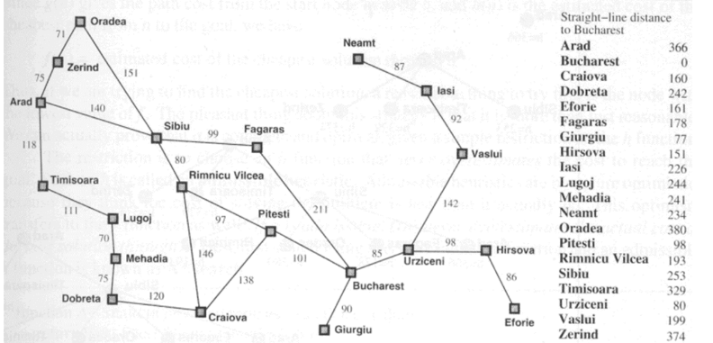

**Code:**

import heapq

# Define the graph as a dictionary where each node has a dictionary of connected nodes and their distances

graph = {

'Arad': {'Zerind': 75, 'Timisoara': 118, 'Sibiu': 140},

'Zerind': {'Arad': 75, 'Oradea': 71},

'Oradea': {'Zerind': 71, 'Sibiu': 151},

'Timisoara': {'Arad': 118, 'Lugoj': 111},

'Lugoj': {'Timisoara': 111, 'Mehadia': 70},

'Mehadia': {'Lugoj': 70, 'Drobeta': 75},

'Drobeta': {'Mehadia': 75, 'Craiova': 120},

'Craiova': {'Drobeta': 120, 'Rimnicu Vilcea': 146, 'Pitesti': 138},

'Sibiu': {'Arad': 140, 'Oradea': 151, 'Fagaras': 99, 'Rimnicu Vilcea': 80},

'Rimnicu Vilcea': {'Sibiu': 80, 'Craiova': 146, 'Pitesti': 97},

'Fagaras': {'Sibiu': 99, 'Bucharest': 211},

'Pitesti': {'Rimnicu Vilcea': 97, 'Craiova': 138, 'Bucharest': 101},

'Bucharest': {'Fagaras': 211, 'Pitesti': 101, 'Giurgiu': 90, 'Urziceni': 85},

'Giurgiu': {'Bucharest': 90},

'Urziceni': {'Bucharest': 85, 'Hirsova': 98, 'Vaslui': 142},

'Hirsova': {'Urziceni': 98, 'Eforie': 86},

'Eforie': {'Hirsova': 86},

'Vaslui': {'Urziceni': 142, 'Iasi': 92},

'Iasi': {'Vaslui': 92, 'Neamt': 87},

'Neamt': {'Iasi': 87}

}

# Define a heuristic function. Here, straight-line distances to Bucharest are used as heuristics.

heuristic = {

'Arad': 366, 'Zerind': 374, 'Oradea': 380, 'Timisoara': 329,

'Lugoj': 244, 'Mehadia': 241, 'Drobeta': 242, 'Craiova': 160,

'Sibiu': 253, 'Rimnicu Vilcea': 193, 'Fagaras': 178, 'Pitesti': 98,

'Bucharest': 0, 'Giurgiu': 77, 'Urziceni': 80, 'Hirsova': 151,

'Eforie': 161, 'Vaslui': 199, 'Iasi': 226, 'Neamt': 234

}

def a_star_search(graph, start, goal):

# Priority queue to hold the nodes to explore

open_list = []

heapq.heappush(open_list, (0 + heuristic[start], 0, start, []))

# Set to hold explored nodes

closed_list = set()

while open_list:

# Get the node with the lowest f(n) = g(n) + h(n)

_, cost, current_node, path = heapq.heappop(open_list)

if current_node in closed_list:

continue

# Add current node to the closed list

closed_list.add(current_node)

# Path to current node

path = path + [current_node]

# Check if we have reached the goal

if current_node == goal:

return path, cost

for neighbor, distance in graph[current_node].items():

if neighbor not in closed_list:

total_cost = cost + distance

heapq.heappush(open_list, (total_cost + heuristic[neighbor], total_cost, neighbor, path))

return None, None

# Execute A* search from Arad to Bucharest

path, cost = a_star_search(graph, 'Arad', 'Bucharest')

print("Optimal Path:", path)

print("Total Cost:", cost)

**Output:**



**Task 2: Implement Greedy Best First Search**

**Objectives:**

The program implements the Greedy Best-First Search algorithm to find an optimal path between Arad and Bucharest in the given map of Romania.

**Task Name:**

Write a program to implement Greedy Best First Search algorithm from figure to find an optimal path between Arad and Bucharest.

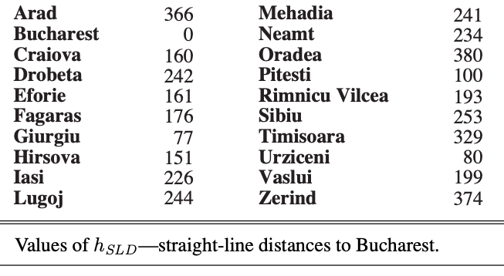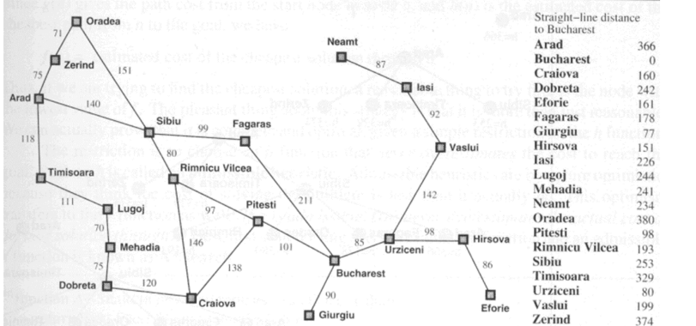

**Code:**

import heapq

# Define the graph as an adjacency list

graph = {

'Arad': [('Zerind', 75), ('Sibiu', 140), ('Timisoara', 118)],

'Zerind': [('Oradea', 71), ('Arad', 75)],

'Oradea': [('Sibiu', 151), ('Zerind', 71)],

'Sibiu': [('Oradea', 151), ('Arad', 140), ('Fagaras', 99), ('Rimnicu Vilcea', 80)],

'Timisoara': [('Arad', 118), ('Lugoj', 111)],

'Lugoj': [('Timisoara', 111), ('Mehadia', 70)],

'Mehadia': [('Lugoj', 70), ('Drobeta', 75)],

'Drobeta': [('Mehadia', 75), ('Craiova', 120)],

'Craiova': [('Drobeta', 120), ('Rimnicu Vilcea', 146), ('Pitesti', 138)],

'Rimnicu Vilcea': [('Sibiu', 80), ('Craiova', 146), ('Pitesti', 97)],

'Fagaras': [('Sibiu', 99), ('Bucharest', 211)],

'Pitesti': [('Rimnicu Vilcea', 97), ('Craiova', 138), ('Bucharest', 101)],

'Bucharest': [('Fagaras', 211), ('Pitesti', 101), ('Giurgiu', 90), ('Urziceni', 85)],

'Giurgiu': [('Bucharest', 90)],

'Urziceni': [('Bucharest', 85), ('Hirsova', 98), ('Vaslui', 142)],

'Hirsova': [('Urziceni', 98), ('Eforie', 86)],

'Eforie': [('Hirsova', 86)],

'Vaslui': [('Urziceni', 142), ('Iasi', 92)],

'Iasi': [('Vaslui', 92), ('Neamt', 87)],

'Neamt': [('Iasi', 87)],

}

# Define the straight-line distances to Bucharest

straight_line_distances = {

'Arad': 366,

'Bucharest': 0,

'Craiova': 160,

'Drobeta': 242,

'Eforie': 161,

'Fagaras': 176,

'Giurgiu': 77,

'Hirsova': 151,

'Iasi': 226,

'Lugoj': 244,

'Mehadia': 241,

'Neamt': 234,

'Oradea': 380,

'Pitesti': 100,

'Rimnicu Vilcea': 193,

'Sibiu': 253,

'Timisoara': 329,

'Urziceni': 80,

'Vaslui': 199,

'Zerind': 374,

}

def greedy_best_first_search(start, goal):

# Priority queue to store the nodes to be explored

priority_queue = []

heapq.heappush(priority_queue, (straight_line_distances[start], start))

# Set to keep track of visited nodes

visited = set()

# Dictionary to store the path

came_from = {}

while priority_queue:

# Get the node with the smallest heuristic value

_, current = heapq.heappop(priority_queue)

# If we reached the goal, reconstruct the path

if current == goal:

path = []

while current in came_from:

path.append(current)

current = came_from[current]

path.append(start)

path.reverse()

return path

# Mark the current node as visited

visited.add(current)

# Explore the neighbors

for neighbor, cost in graph[current]:

if neighbor not in visited:

heapq.heappush(priority_queue, (straight_line_distances[neighbor], neighbor))

came_from[neighbor] = current

return None

# Test the function

start = 'Arad'

goal = 'Bucharest'

path = greedy_best_first_search(start, goal)

print(f"Path from {start} to {goal}: {path}")

